|  |  |  |  |  |
| --- | --- | --- | --- | --- |
| Name: Nishchal Sreevathsa |  |  |  |  |

Performing Reconnaissance from the WAN

Ethical Hacking & Lab 1

Table of Contents

1. Executive Summary 2

Highlights

Objectives

1. Lab Description Details 2

Include Steps Taken, Notes, & Screen Shots demonstrating completion of lab objectives

1. Supporting Evidence 12
2. Conclusion & Wrap-Up 14

Summary with observations, Success & Failures, Challenges

# Executive Summary

## Highlights

|  |  |
| --- | --- |
|  | 1. Banner Grabbing: By connecting to the external IP address of the pfSense firewall, we can do banner grabbing. Nmap will be used to scan the network and discover which ports are open. 2. Service Detection: We'll try to learn what programs and operating systems are installed on the internal computers covered by the firewall that faces outside. 3. Remote Desktop Protocol(RDP): We will start an RDP session and log into the Microsoft Windows Server using those credentials. |

## Objectives

|  |  |
| --- | --- |
|  | In this lab, we acquire data from the WAN Network by banner-grabbing hosts that are in the same topology and then utilize tools to save user credentials and breach the system. |

# Lab Description Details

**Step 1:** Accessed the external Kali Linux2 machine on the topology then machine got booted and entered **root** as username and entered **toor** as password.

**Step 2:** After opening the terminal, In order to accomplish banner grabbing, we need to identify the open ports. Command: **nmap www.campus.edu**

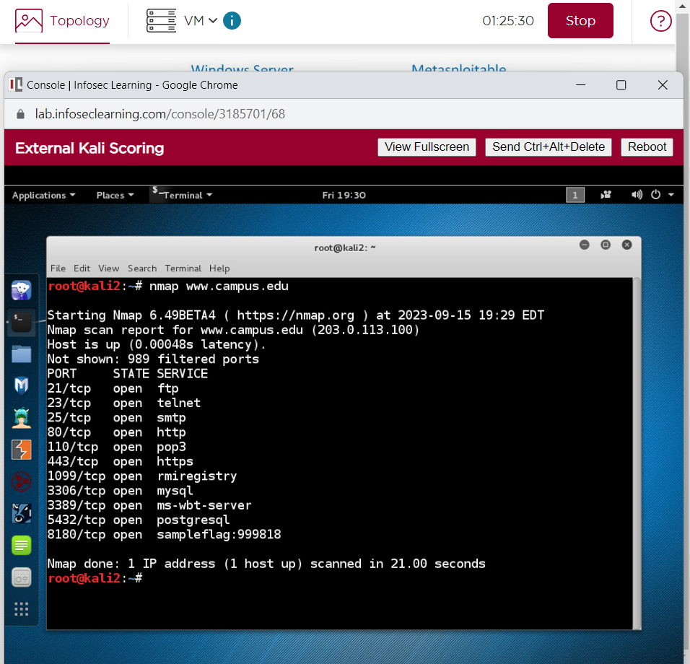

Found the Sample flag: **999818** for TCP open port 8180.

**Step 3:** Utilized various commands to gather more details about the services in order to carry out the banner grab. The TELNET and Netcat(nc) commands have been used.

Commands:

**nc www.campus.edu 21**

**telnet www.campus.edu 23**

**telnet www.campus.edu 25**

**nc www.campus.edu 80**

**telnet www.campus.edu 110**

**nc www.campus.edu 443**

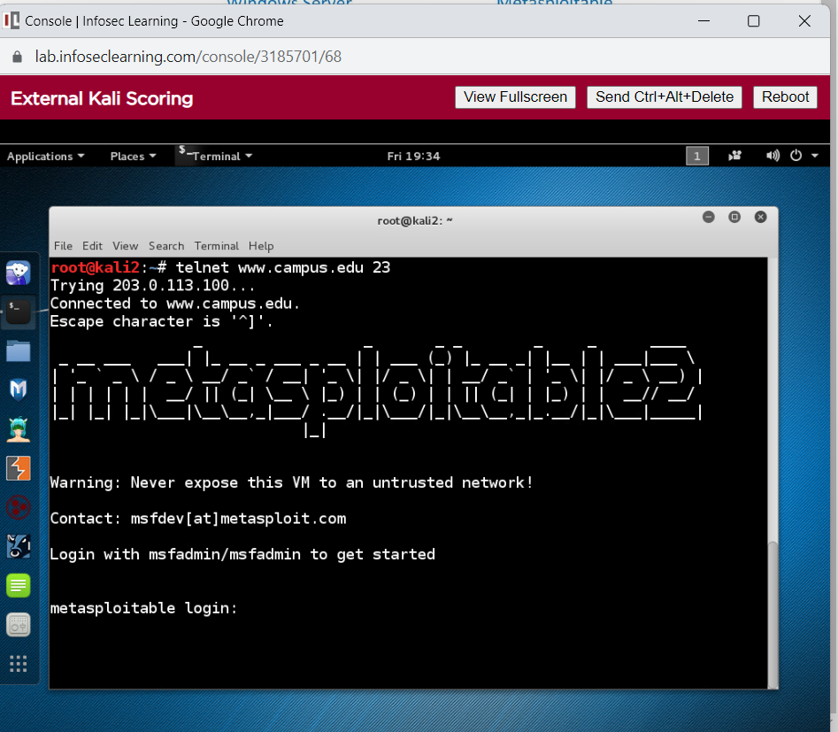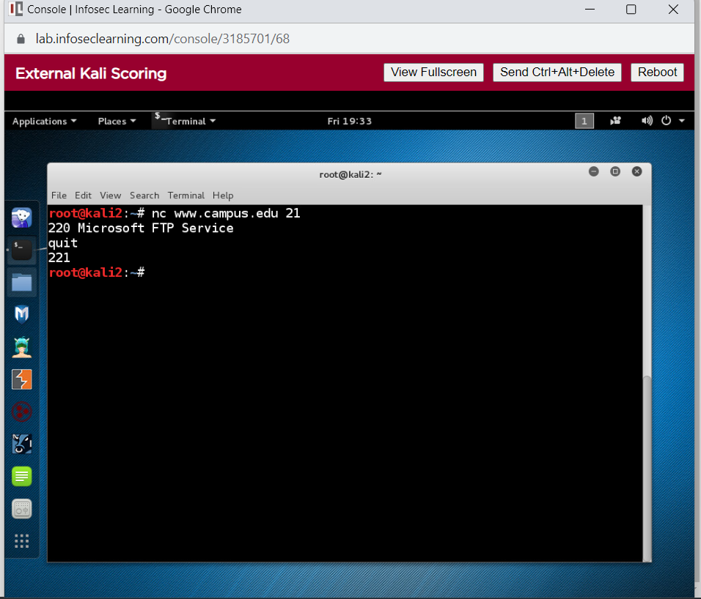

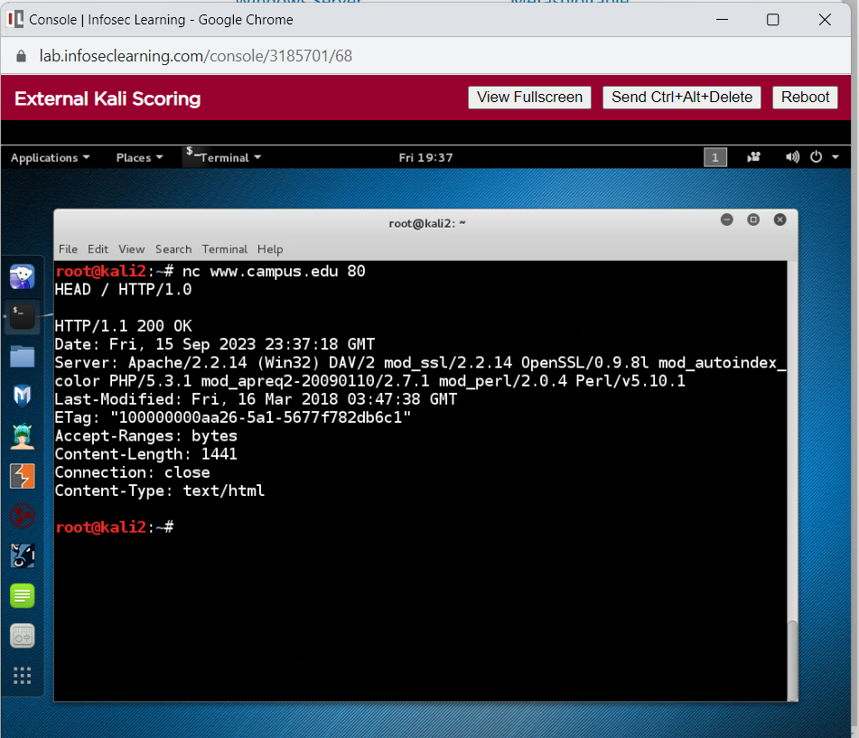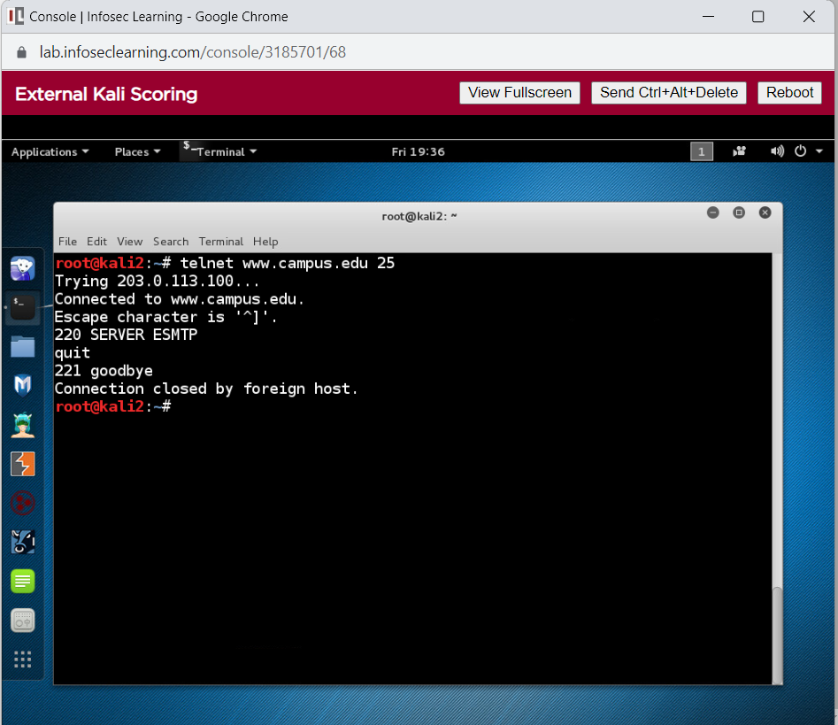

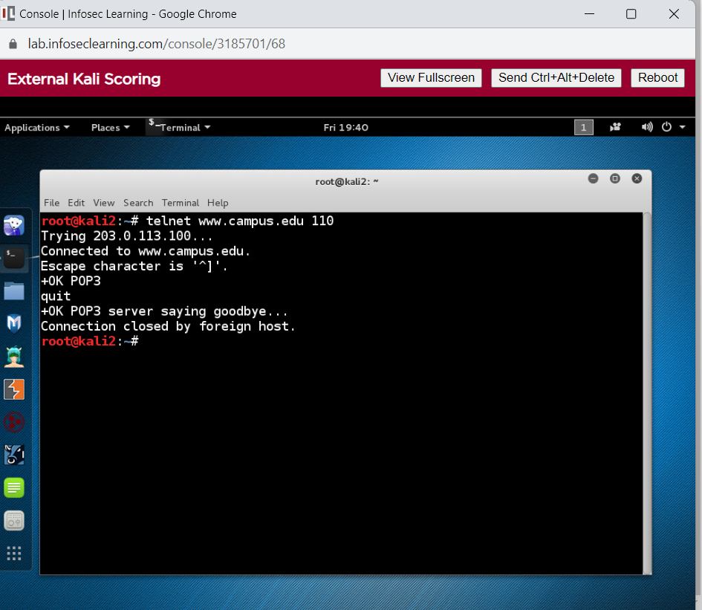

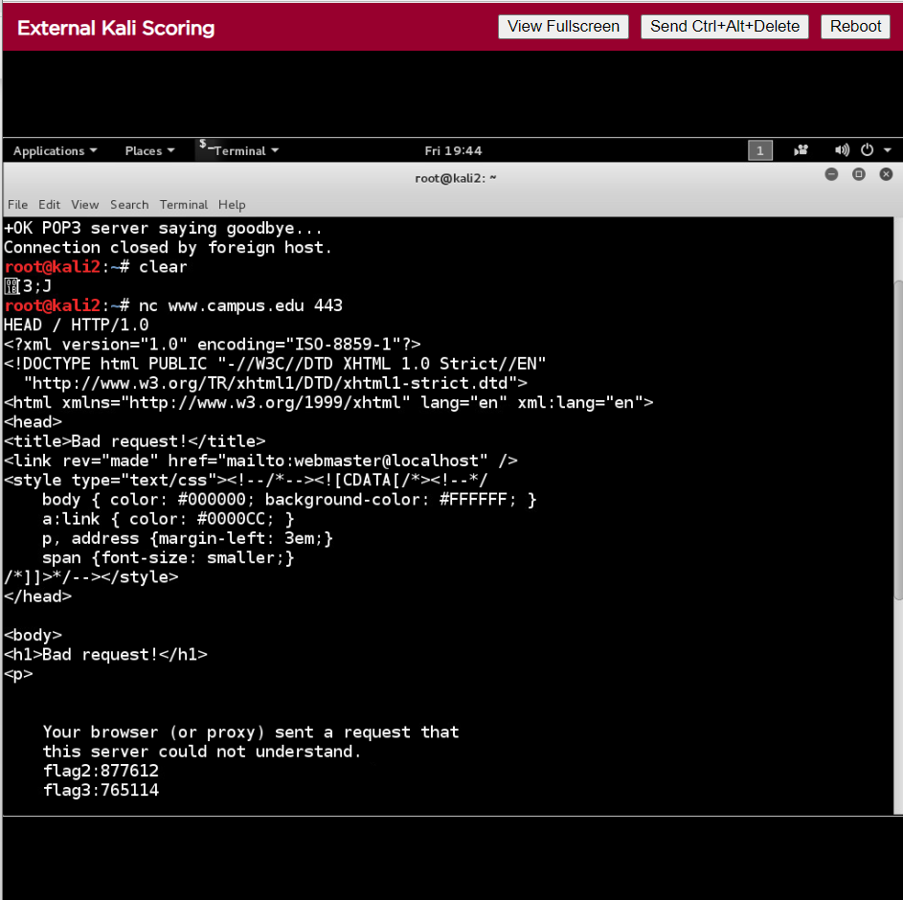Captured the flag number of **Flag2: 877612 and Flag 3: 765115** which was found under open port number 443 which had HTTPS as Service.

**Step4:** Used nmap command to identify the available switches.

Command: #**nmap**

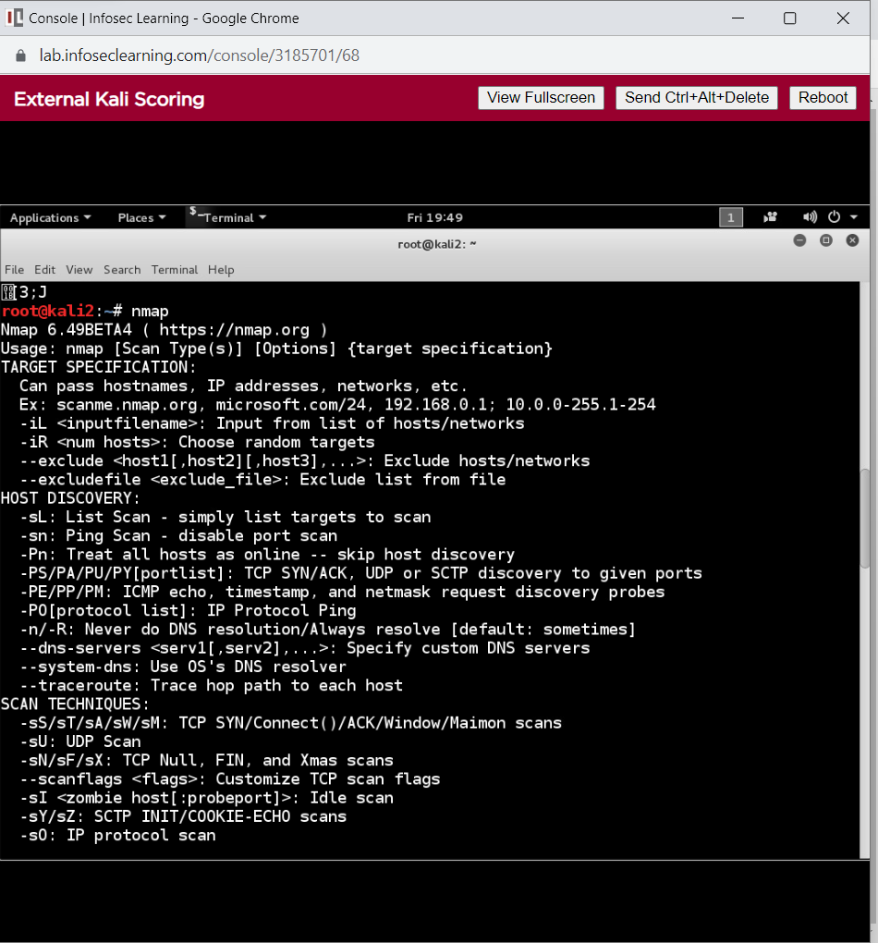

**Step5:** Advanced Nmap scanning is implemented to do a service and script scan of the target on various ports.

Command:

**nmap -sV -sC www.campus.edu -p 21**

**nmap -sV -sC www.campus.edu -p 23**

**nmap -sV -sC www.campus.edu -p 25**

**nmap -sV -sC www.campus.edu -p 80**

**nmap -sV -sC www.campus.edu -p 110**

**nmap -sV -sC www.campus.edu -p 443**

**nmap -sV -sC www.campus.edu -p 1099**

**nmap -sV -sC www.campus.edu -p 3306**

**nmap -sV -sC www.campus.edu -p 3389**

**nmap -sV -sC www.campus.edu -p 5432**

**nmap -sV -sC www.campus.edu -p 8180**

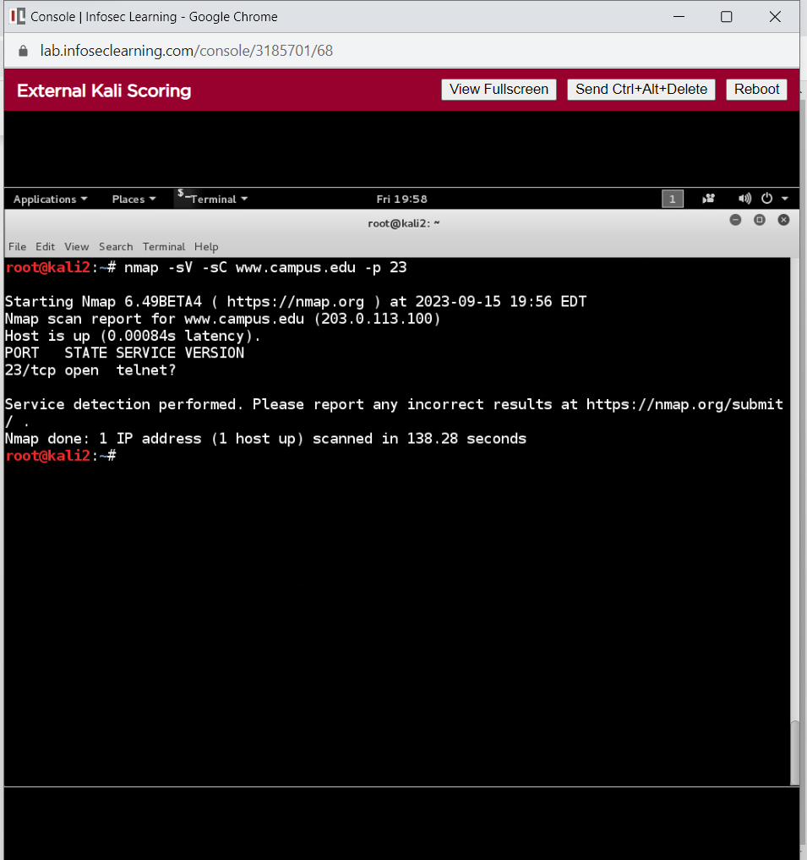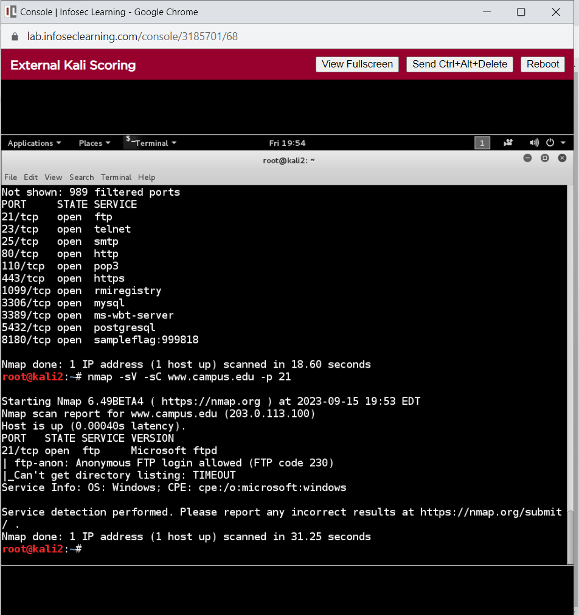

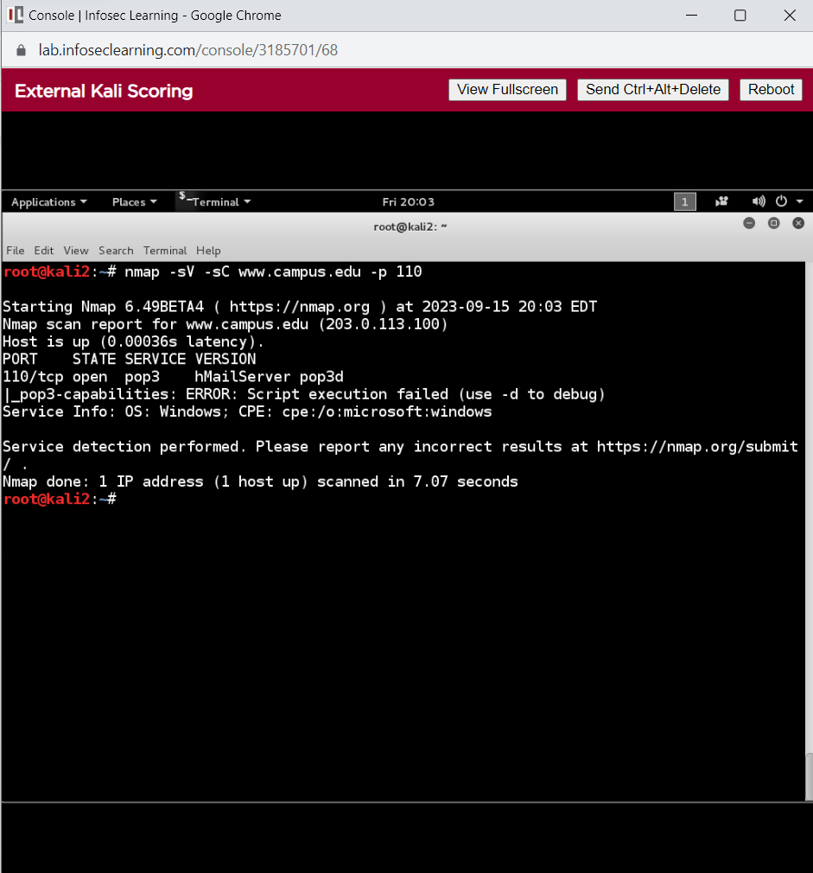

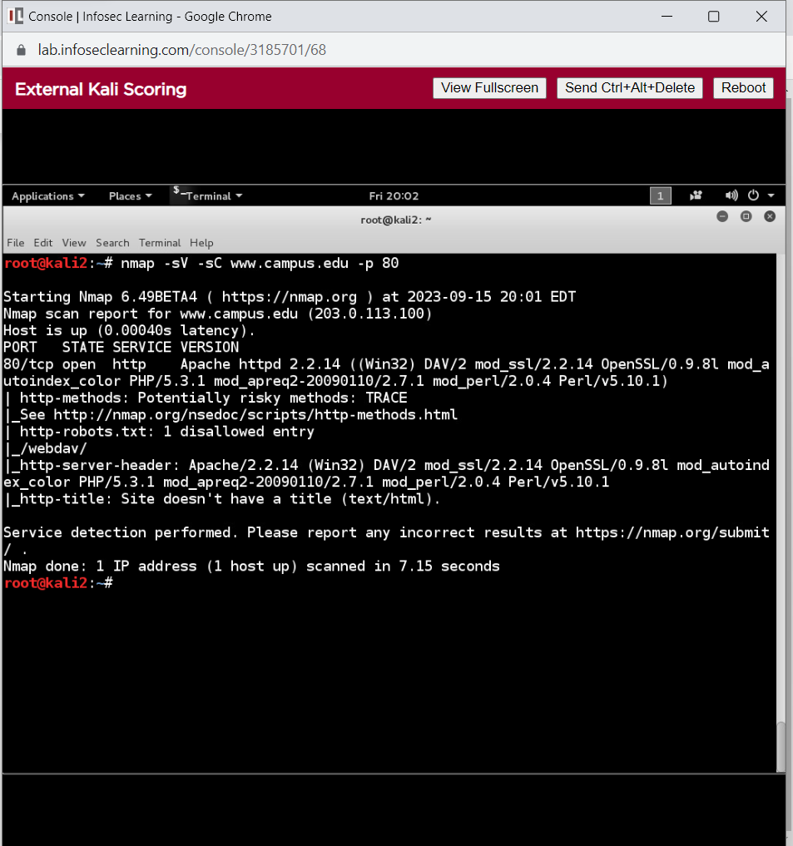

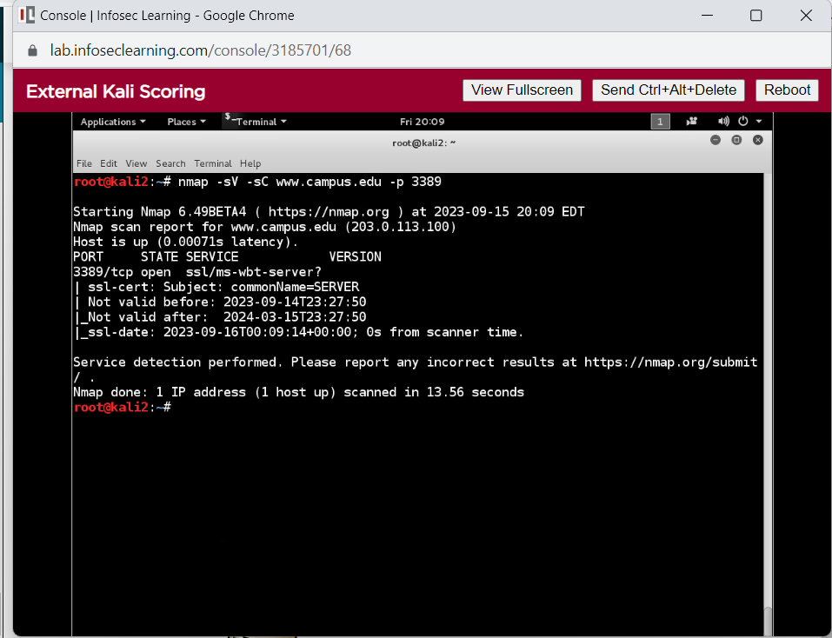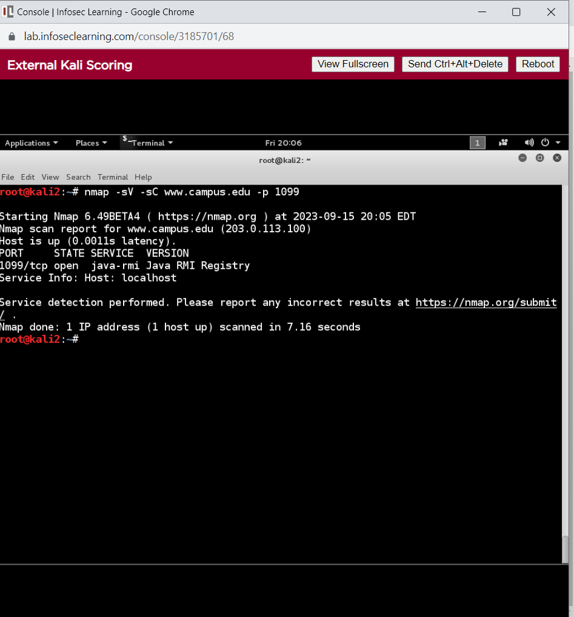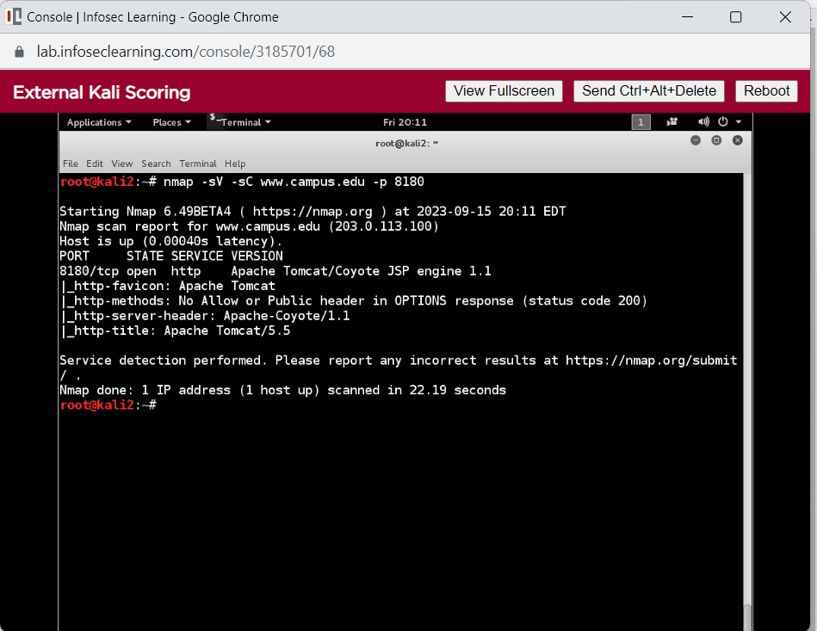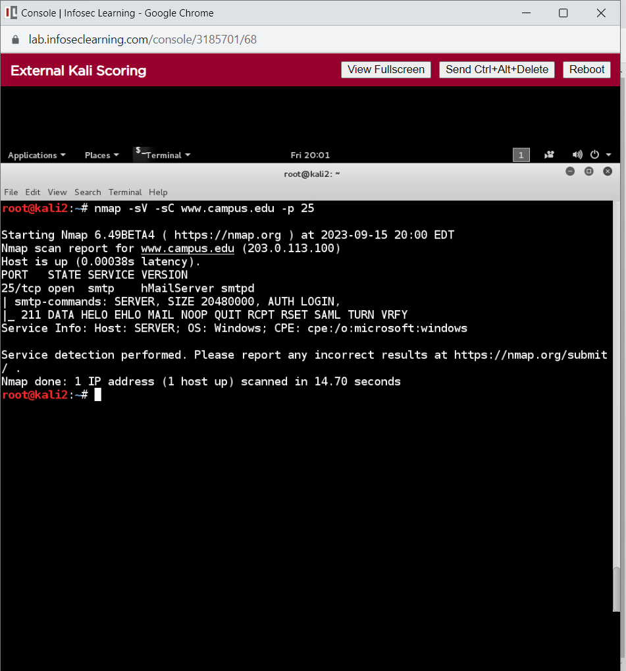

**Step6:** We are able to use the login and password provided by the telnet service to obtain the administrator's hash and decode it.

Command: **telnet** [**www.campus.edu**](http://www.campus.edu)

Details for msf login are login: **msfadmin** and password same as login id.

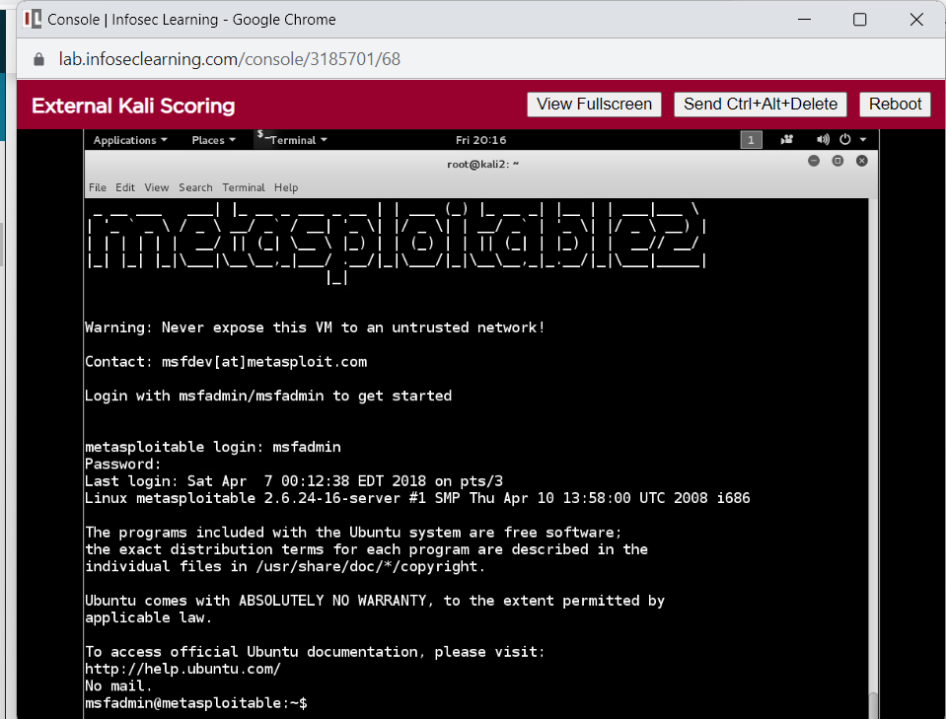

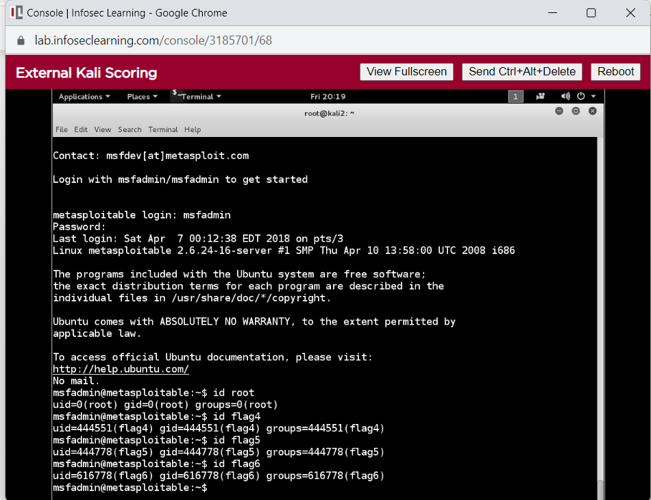

Captured the Flag4: **444551**, Flag 5: **444778** and flag: **616778**.

**Step7:** Go to the shadow file after logging into the system to view the hashes.

Command: **# sudo tail /etc/shadow**

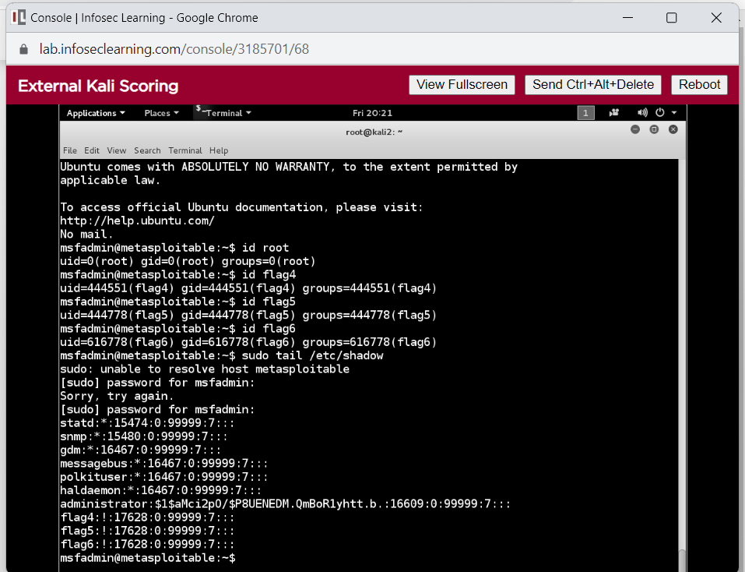

**Step8:** We obtained the administrator's hash, cracked it, and obtained the password. Copy the hash and store it in the pass.txt file.

Command: **# leafpad pass.txt**

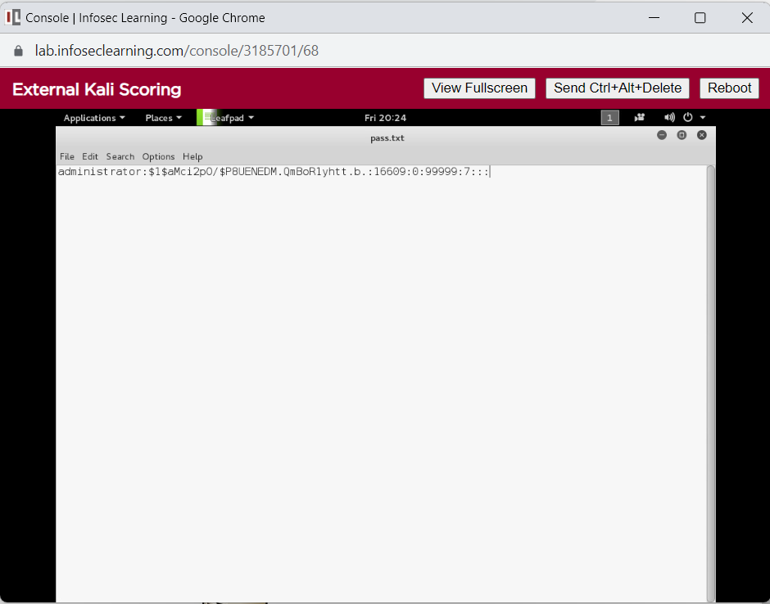

**Step9:** Enter the command: **john pass.txt** to decipher the hash in the file pass.txt.

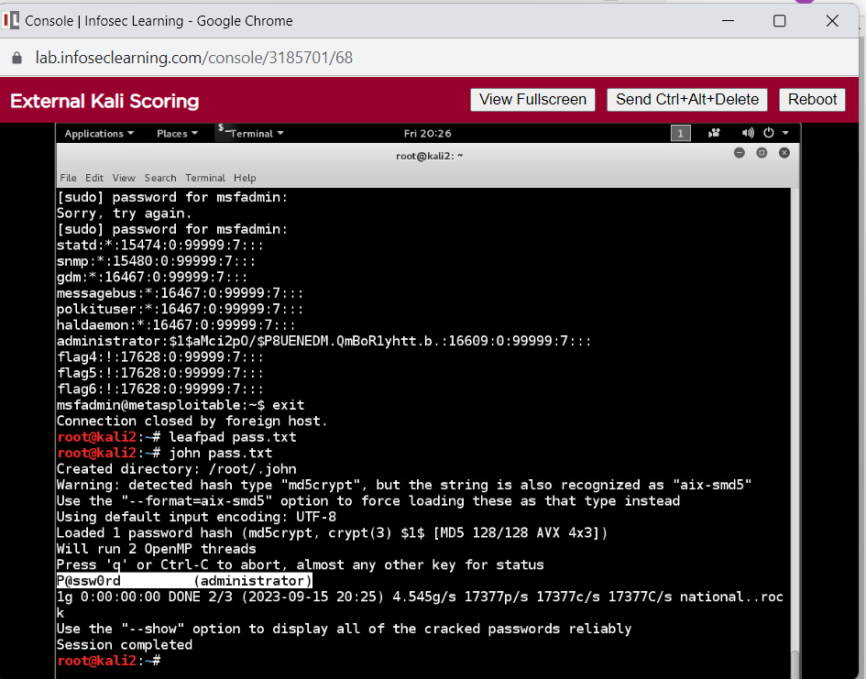

**Step 10:** Connect to target on port 3389.

Command: **rdesktop www.campus.edu**

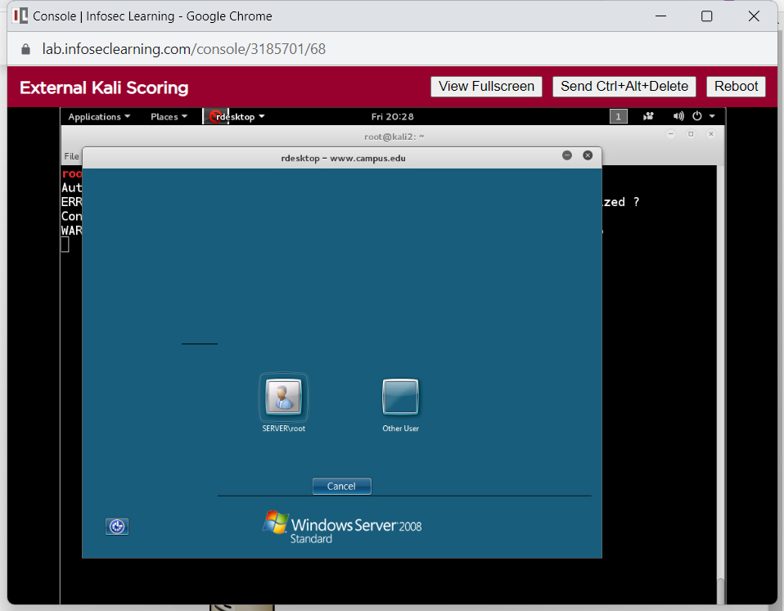

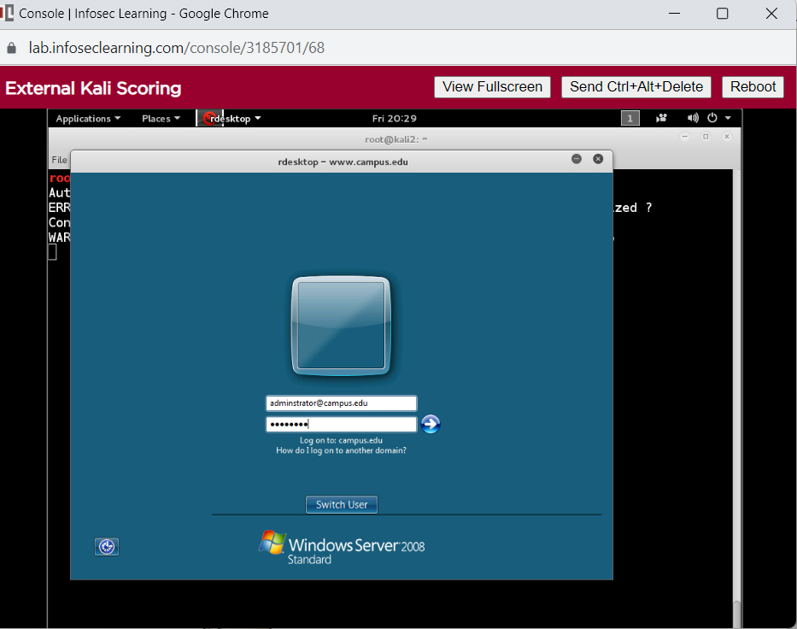**Step 11:** Clicked on Other User and logged in using [**administrator@campus.edu**](mailto:administrator@campus.edu) as login id and password is **P@ssw0rd**. The system is now successfully logged in.

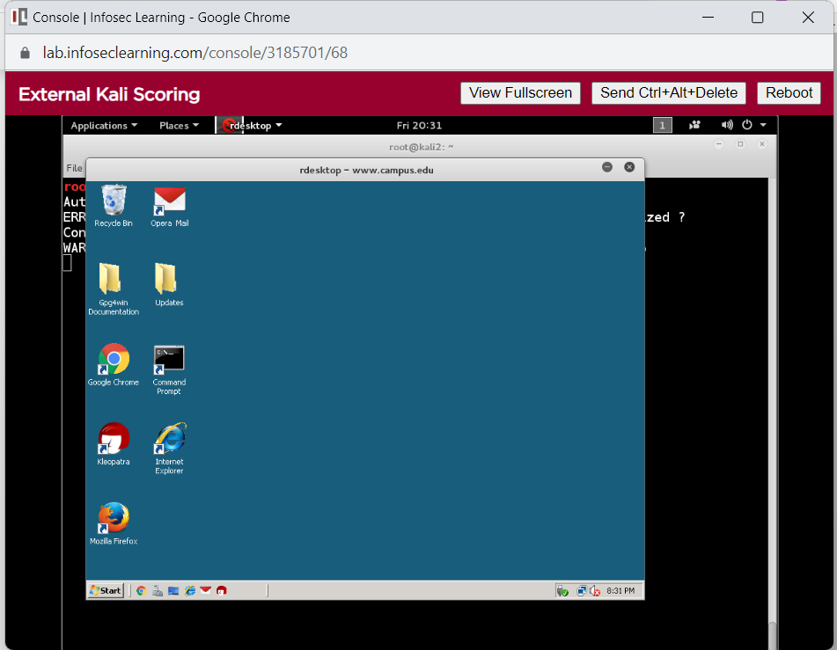

# Supporting Evidence

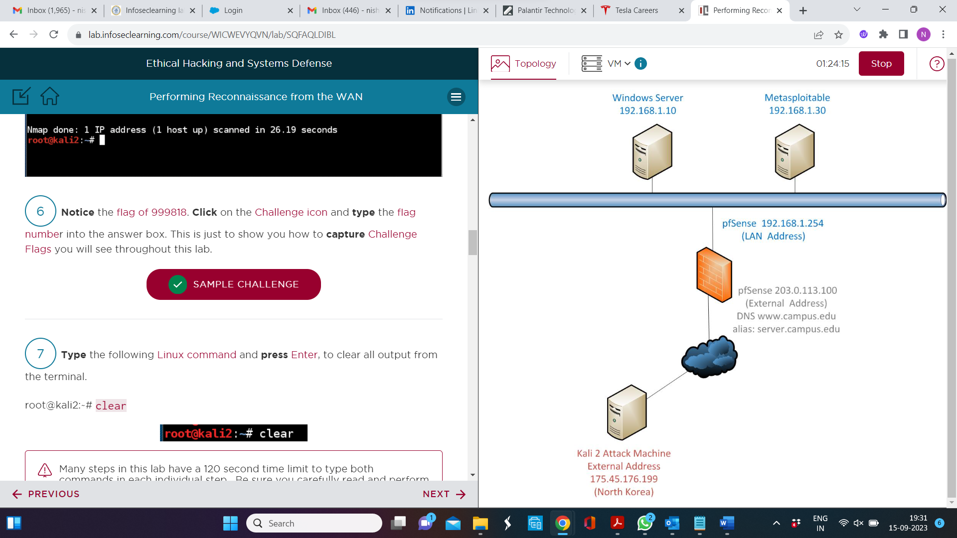

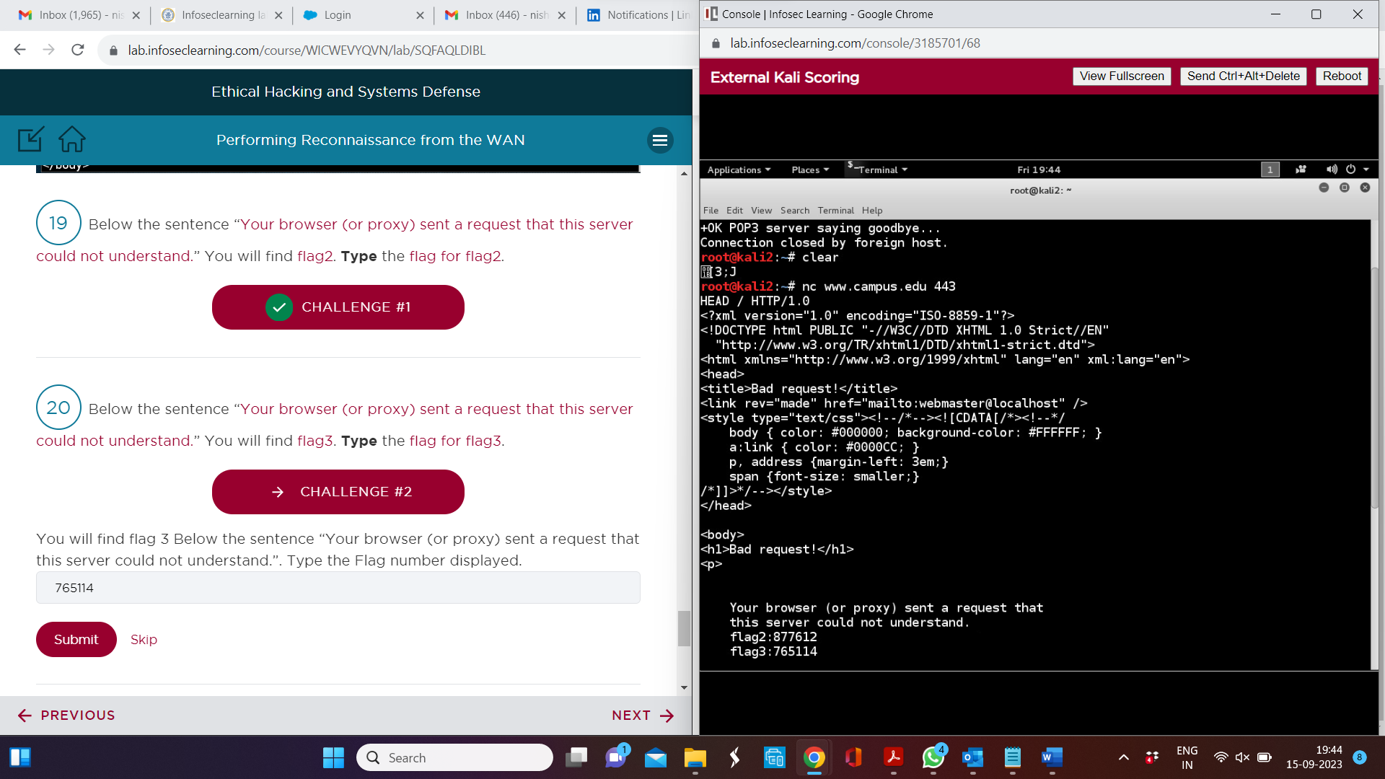

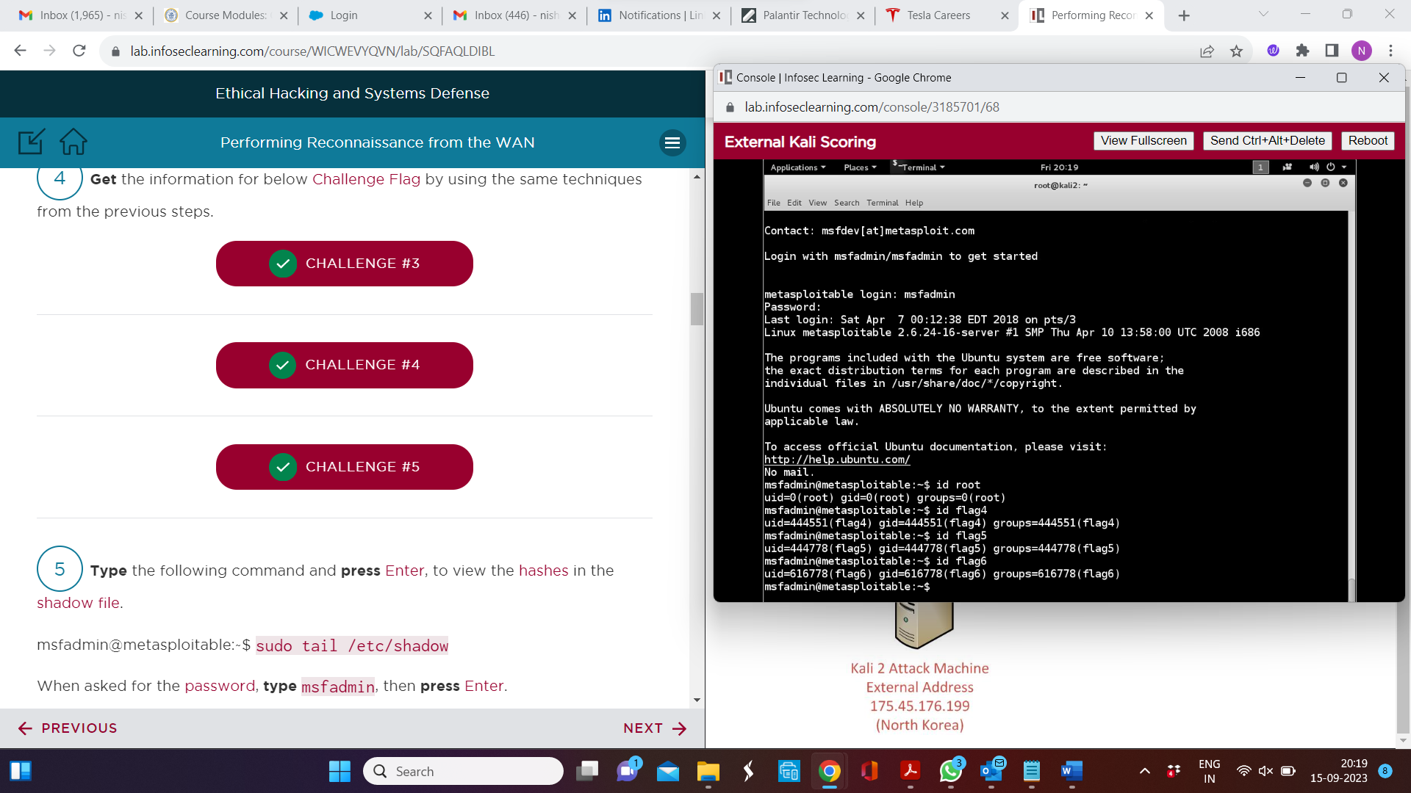

# Conclusion & Wrap-Up

## Summary with observations, Success & Failures, Challenges

Using a Kali machine with an external IP address on the WAN (wide area network), we conducted reconnaissance in this lab. Using nmap and John the Ripper, the attacker will utilize the stolen credentials to get remote desktop access to the Windows Server PC.